**PRICE:** [$40.99](https://www.amazon.com/gp/slredirect/picassoRedirect.html/ref=sspa_dk_detail_3?ie=UTF8&adId=A06543423KG08364MQR6U&qualifier=1687597940&id=189195516927233&widgetName=sp_detail_thematic&url=%2Fdp%2FB08BY7XPJZ%2Fref%3Dsspa_dk_detail_3%3Fpsc%3D1%26pd_rd_i%3DB08BY7XPJZ%26pd_rd_w%3D64Bai%26content-id%3Damzn1.sym.386c274b-4bfe-4421-9052-a1a56db557ab%26pf_rd_p%3D386c274b-4bfe-4421-9052-a1a56db557ab%26pf_rd_r%3D8VHCNJFRQNAW9NF73SMY%26pd_rd_wg%3DPw5nB%26pd_rd_r%3D69facf77-c800-45df-8086-cec16dd79b14%26s%3Dtoys-and-games%26sp_csd%3Dd2lkZ2V0TmFtZT1zcF9kZXRhaWxfdGhlbWF0aWM)

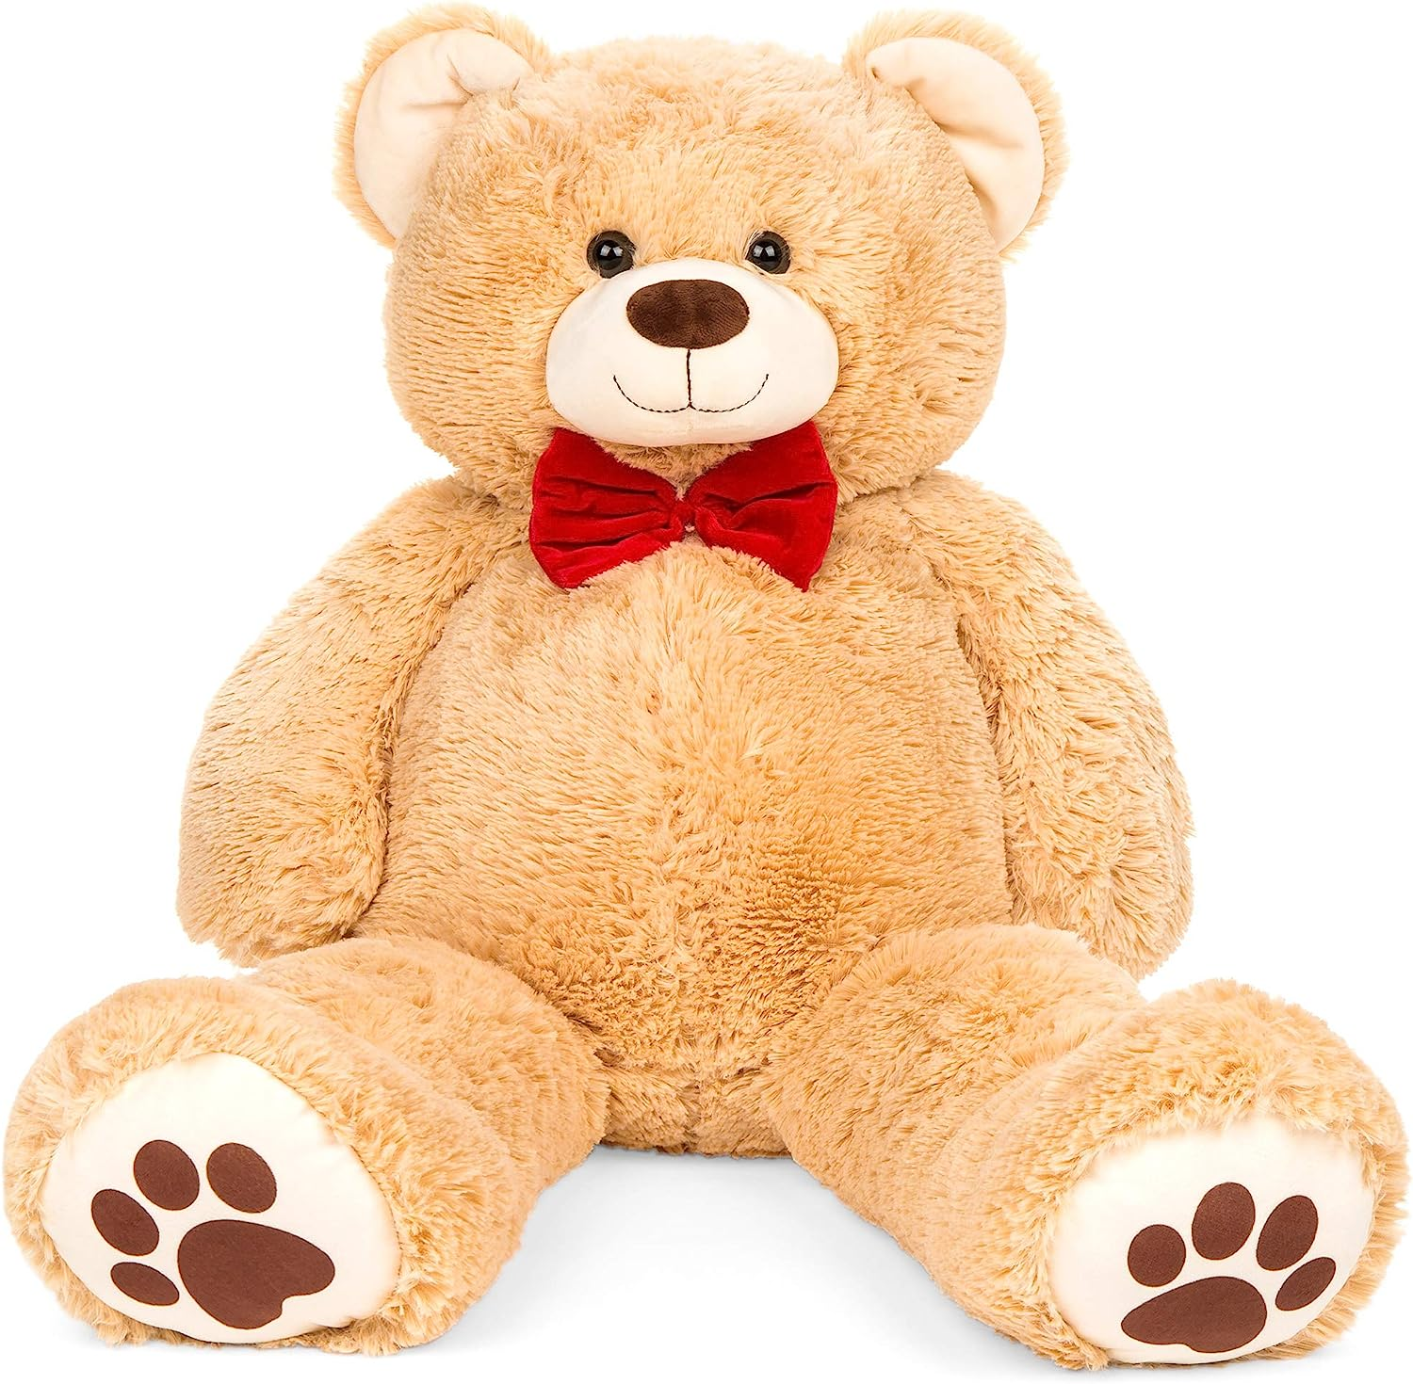

ID: S-06

**Size:** 20inch

**Color:** Tan

* 100% natural soft fur
* 20 inches tall: The cute teddy bear measures 20 inch from head to toe (17 inch in sitting position), perfect for little kids hugging and snuggling, it’s easy for you to take it anywhere, this cute teddy bear can accompany you anytime and bring you happiness forever
* Premium Stuffing Material: Each soft cuddle teddy bear is made with polyester and plush material, the stuffing is soft and slightly floppy, perfect for hugs and cuddles
* Durable & Safe: Lock-washer eyes and stitched nose ensures safe and durable use; the eyes cannot be chewed or picked off easily by young children; Extra soft fur, black eyes, cute nose and facial features
* Huggable and Adorable: These soft plush teddy bear stuffed animal toys are perfect for hugging and snuggling, resting on, and bringing smiles and comfort, a great graduation gift for kids, perfect for themed party decoration gifts for the wife, girlfriend, granddaughter, grandson, friends
* Great Gift: These soft fluffy teddy bear stuffed animals are a great gift for holidays like Christmas, Thanksgiving, Easter and Valentine’s Day; Plush animals always make a great get-well gift, birthday present, baby shower gift and friend for first communion